Drawing a plot first. Black is the customers who did not purchase a new computer, red is who purchased.

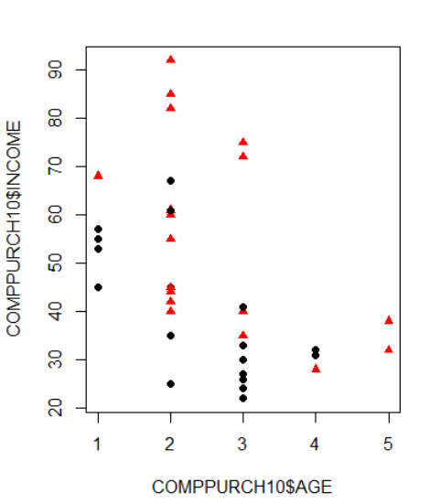

Fitting a logit model to data

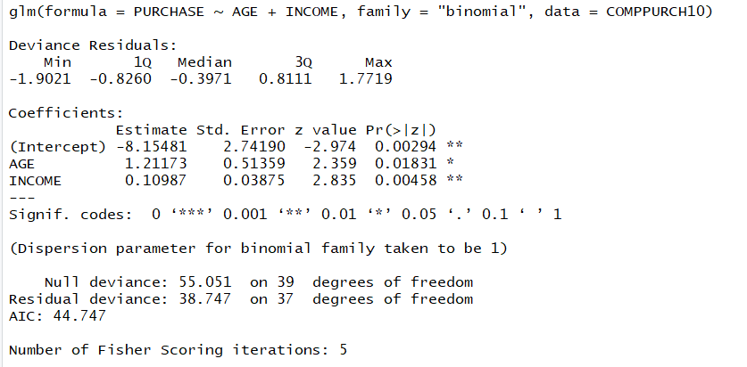

Z value at 95% is 1.96.



#1

To test whether INCOME variable is important or not in the logistic regression function we need to test hypotheses:

H_0: Beta_1 = 0

H_a: Beta_1 <> 0

Reject H_0 if Z > 1.96 or Z < 1.96.

While Z = 2.835 > 1.96, so reject H_0. So, INCOME variable is important in the logistic regression function.

#2

To test whether AGE variable is important or not in the logistic regression function we need to test hypotheses:

H_0: Beta_2 = 0

H_a: Beta_2 <> 0

Reject H_0 if Z > 1.96 or Z < 1.96.

While Z = 2.359 > 1.96, so reject H_0. So, AGE variable is important in the logistic regression function.

Above all, both INCOME and AGE are useful in predicting whether a customer will purchase a new computer or not.